

UNIVERSITY OF RWANDA
COLLEGE OF SCIENCE AND TECHNOLOGY
COMPUTER ENGINEERING Y4
GAKO CAMPUS
MOBILE COMMUNICATION

GROUP 1 MEMBERS
1. MUHIRE VALENTIN 223026677
2.RUBIMBURA DAVID 221014566
3.IRADUKUNDA REOBOTH 223026686

1. Introduction
This report presents the implementation and results of three mini projects from Unit 1 of the Mobile Communications laboratory. The work was completed using Python, NumPy and Matplotlib. The first project models free-space link budgets and coverage range, the second compares FDD and TDD resource allocation under asymmetric traffic, and the third validates the simplified mobile-generation comparison and implements a rule-based recommender.

2. Mini Project 1.1 – Link Budget and Coverage Range
The objective was to translate the link-budget and free-space path-loss equations from Section 1.10 into executable Python code and compare received power for 700 MHz and 28 GHz. The simulation used 500 logarithmically spaced distance points from 0.01 km to 100 km.
Parameter | Value
Transmit power | 40 dBm
TX antenna gain | 15 dBi
RX antenna gain | 0 dBi
Other losses | 3 dB
Receiver sensitivity | −100 dBm
Distance range | 0.01–100 km
Reference distance | 1 km
2.1 Parameters and equations
The implemented free-space path-loss equation was:
Lpath=20log⁡10(dkm)+20log⁡10(fMHz)+32.44Lpath​=20log10​(dkm​)+20log10​(fMHz​)+32.44
The received power was then calculated using:
P_RX = P_TX + G_TX − L_path + G_RX − L_other.

2.2 Base results
Band | Path loss at 1 km | P_RX at 1 km | Link margin | Maximum range
700 MHz | 89.26 dB | −37.26 dBm | 62.74 dB | >100 km in simulation
28 GHz | 121.30 dB | −69.30 dBm | 30.70 dB | 33.95 km
At the 1 km reference point, the 28 GHz path loss is about 32.04 dB greater than the 700 MHz path loss. In the 0.01–100 km simulation interval, the 700 MHz received power remains above the −100 dBm sensitivity threshold, so no crossing occurs within the simulated range. The 28 GHz curve crosses the threshold at approximately 33.95 km.

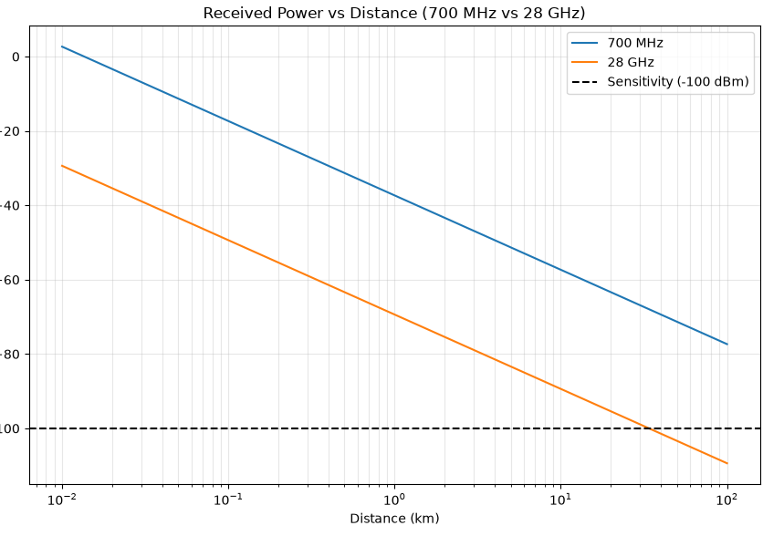
Figure 1. Received power comparison for 700 MHz and 28 GHz.
2.3 Extension tasks
Increasing the 28 GHz transmit antenna gain from 15 dBi to 24 dBi increased the calculated range from 33.95 km to 95.68 km, a factor of approximately 2.82.
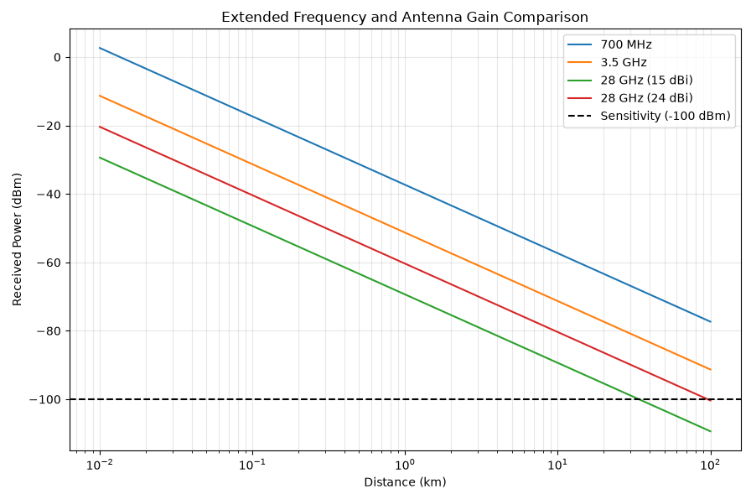
Figure 2. Extended comparison including 3.5 GHz and increased 28 GHz antenna gain.
Adding an 8 dB fading/shadowing loss reduced the 28 GHz range to approximately 13.52 km. The 700 MHz link remained above the sensitivity threshold over the 100 km simulation interval.
For the SNR and capacity extension, a −104 dBm noise floor and 10 MHz bandwidth were used. At 1 km, the calculated SNR values were 66.74 dB for 700 MHz and 34.70 dB for 28 GHz. The corresponding Shannon capacity ceilings were 221.70 Mbps and 115.27 Mbps.
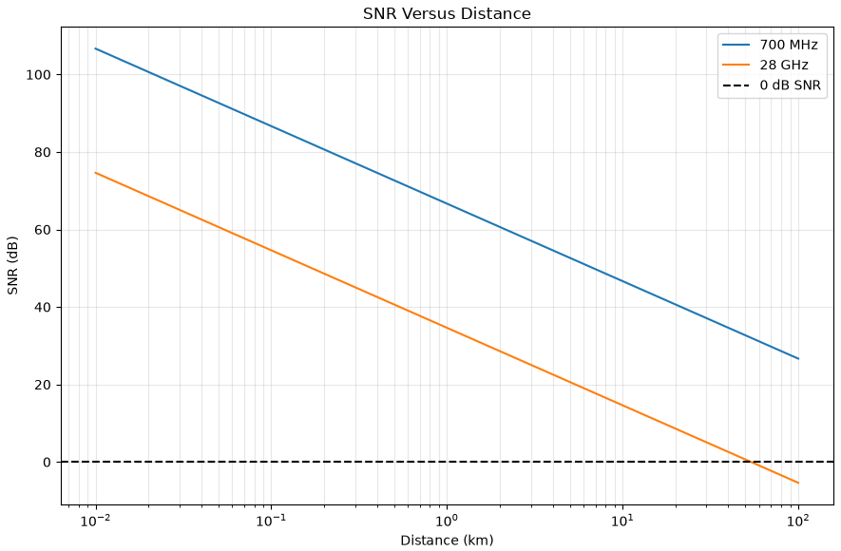
Figure 3. SNR versus distance.
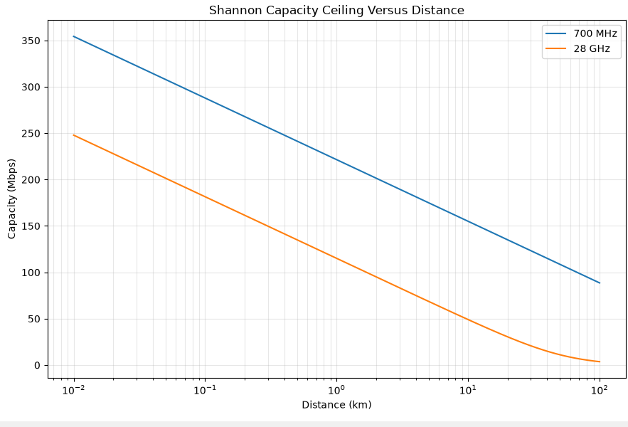
Figure 4. Shannon capacity ceiling versus distance.
When transmit power was doubled, the model represented this as an increase of approximately 3.01 dB. At 1 km, the resulting capacity was about 231.70 Mbps. When bandwidth was doubled from 10 MHz to 20 MHz, the calculated capacity was about 443.40 Mbps. This illustrates the different effects of power and bandwidth within the Shannon-capacity expression.

3. Mini Project 1.2 – FDD and TDD Resource Utilization
The second project implemented simplified FDD and TDD resource-allocation models. The total modeled capacity was 100 Mbps. FDD was divided into fixed 50 Mbps downlink and 50 Mbps uplink channels. TDD used a shared 100 Mbps channel and allocated its usable capacity according to the traffic ratio after guard-period overhead.
3.1 FDD results
Traffic | DL | UL | Total | Utilization
50:50 | 50 | 50 | 100 | 100%
70:30 | 50 | 30 | 80 | 80%
90:10 | 50 | 10 | 60 | 60%
The FDD results show that fixed directional capacity becomes unused when demand is asymmetric. For example, in the 90:10 case the downlink demand exceeds the 50 Mbps fixed downlink allocation, while the uplink channel has unused capacity.
3.2 TDD results and guard overhead
Traffic | 5% guard | 10% guard | 20% guard
50:50 | 95 Mbps | 90 Mbps | 80 Mbps
70:30 | 95 Mbps | 90 Mbps | 80 Mbps
90:10 | 95 Mbps | 90 Mbps | 80 Mbps

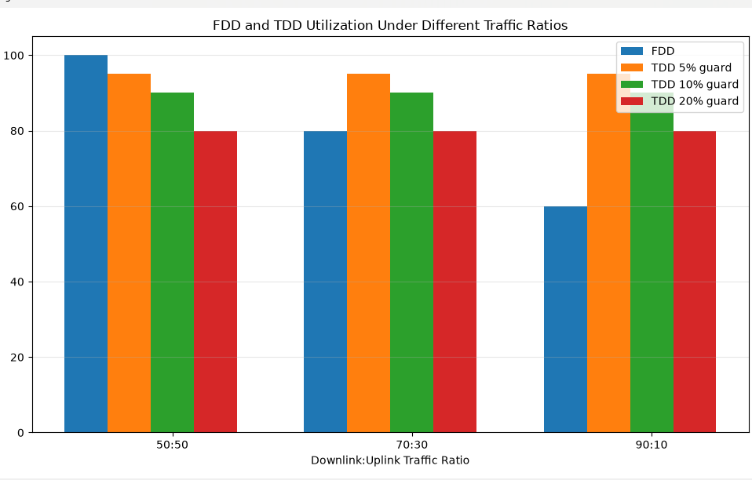
Figure 5. FDD and TDD utilization under different traffic ratios and guard overheads.
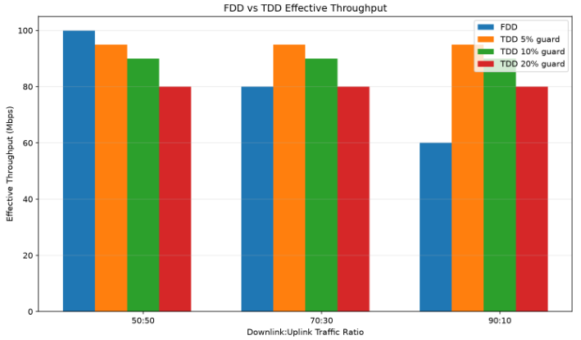
Figure 6. FDD and TDD effective throughput.
The simplified TDD model delivered 95 Mbps, 90 Mbps and 80 Mbps for 5%, 10% and 20% guard overhead respectively. Because the TDD slot allocation was matched to the traffic ratio in each scenario, the same total usable capacity resulted for the three asymmetry cases at a fixed guard overhead. This is a property of the simplified model rather than a claim about every real-world TDD system.

4. Mini Project 1.3 – 0G–6G Validation and Recommender
The third project used a rule-based Python recommender. The program accepts a plain-language communication requirement, searches for generation-related keywords, and returns a generation, matched keywords and a short explanation. Six varied test cases and an intentionally unclear case were included.
4.1 Research validation
Additional sources were consulted to compare the simplified generation table with established standards and industry references. ITU describes the broad standardized evolution from analogue cellular 1G through digital cellular 2G, IMT-2000 3G, IMT-Advanced 4G and IMT-2020 5G. 3GPP provides historical context for the move from analogue 1G to digital 2G and later 3G and LTE/4G systems. GSMA material provides additional descriptions of 1G, 2G and 3G characteristics.
The comparison also showed why a single peak-rate number can be misleading. Generation specifications and technology families evolved through multiple releases, and peak theoretical performance is not equivalent to typical user throughput.
4.2 Problems motivating generational transitions
1G to 2G: analogue systems had capacity and quality limitations and different national standards; digital cellular systems addressed these limitations and improved interoperability.
2G to packet-data extensions and 3G: increasing demand for mobile data required more efficient packet-oriented services and higher data rates.
3G to 4G: growing demand for mobile broadband required substantially higher capacity and data-rate targets.
4G to 5G: mobile networks were expected to support not only enhanced broadband but also low-latency and massive machine communication use cases.
5G to 6G: current IMT-2030 work examines additional capabilities including immersive communication, AI and communication, ubiquitous connectivity, and integrated sensing and communication.
4.3 Recommender test results
Test requirement | Program result
Basic analog mobile voice service | 1G
Digital cellular voice and SMS | 2G
Packet data and early mobile Internet using GPRS | 2.5G
Mobile broadband and video calling | 3G
Low-latency control for a robotic arm | 5G
Integrated sensing and extremely high data rates | 6G
General mobile connectivity without generation-specific terms | No clear match
The built-in test cases were executed as part of the completed script. The resulting classifications were:

5. Discussion
The three projects demonstrate different aspects of mobile-communication system design. The link-budget simulation shows how frequency strongly affects propagation loss under the simplified free-space model, while antenna gain can recover part of the range loss. The FDD/TDD simulation demonstrates the resource allocation trade-off between fixed directional capacity and flexible time sharing. The generation recommender demonstrates how technical capabilities can be connected to communication requirements, while the research validation shows that generation tables are useful summaries but necessarily simplify a more detailed standards history.

6. Conclusion
All three Unit 1 mini projects were implemented and executed successfully. The first project produced link-budget, SNR and capacity results for multiple frequency bands. The second produced FDD/TDD utilization and throughput comparisons for three traffic asymmetry levels and three guard-period assumptions. The third produced a working generation recommender and a research-based validation of the simplified 0G–6G comparison. The source code, numerical results and generated figures are included with the project.
7. References
International Telecommunication Union (ITU), "1990s–2020s — ITU's 160th anniversary," generation history and IMT evolution.
International Telecommunication Union (ITU-R), Recommendation M.2160-0, "Framework and overall objectives of the future development of IMT for 2030 and beyond," 2023.
International Telecommunication Union (ITU), "IMT-Advanced," description of IMT-Advanced capabilities and target data rates.
International Telecommunication Union (ITU-T), "Background — IMT-2000," overview of third-generation mobile systems.
3GPP, "The Mobile Broadband Standard," historical overview of 1G, 2G, 3G and 4G development.
GSMA, "The Spectrum Policy Dictionary," descriptions of 1G, 2G and 3G mobile technologies.
GSMA Intelligence, "Understanding 5G," discussion of mobile technology evolution and 4G.
International Telecommunication Union (ITU), "IMT-2030: Technical requirements for the 6G future," March 2026.

